Technician Project
CNET 227 - Section 003

Network Design for KYJK Labs, Canada

Members (Group 4):
Remigio, Kevin Neil - 301096069
Thozhuthumparambil, Joe Jaison - 301102758
Le, Khac Luc - 301034418
Luo, Yujia – 300919260

Professor:
Musaazi, Emmanuel

ABSTRACT
We designed and implemented a fully functioning network infrastructure for KYJK Labs, Canada which composes of eight (8) departments: Sales, Marketing, Directors, HR, E-commerce, Finance, Production, and R&D. The aim of the network infrastructure was to enable a fast, efficient, and secure communication and exchange of information in addition to the requirements specified by KYJK Labs. This was achieved with the use of Cisco devices for switching, routing, and automatic IP addressing using DHCP servers. In addition, Microsoft Windows Server 2016 was used for the configuration of administrative services and setting up of client’s devices/equipment and applications. The project was completed in a span of four (4) months and had a total project cost of C$ 59,116.68.

Table of Contents

Abstract 2

Chapter I – Introduction 4
- Background Information 4
- Problem Statement 4
- Objectives of the Research 4
- Executive Summary 4

Chapter II - Planning stage 5
- Proposal 5
- Deliverables 7
- Procedures 7
- Budget 7
- Risk Analysis / Scope and Limitations 8

Chapter III – Technical Section (Network Design and Implementation) 10
- Final Topology and Design Specifications 10
- IP addressing table (Static and Dynamic) 11
VLAN table 11
DHCP server pools 12
- List of Hardware and Software Requirements 12
- Switch and Router configurations (Cisco Packet Tracer) 14
VLAN configurations 14
Inter-VLAN routing 15
Routing protocol (RIPv2) 17
DHCP server 18
Connectivity/Service Testing 21
- Server configurations 25
Domain Controller 25
User and Groups 26
DHCP Server 27
DNS Server 28
FTP Server 29

Chapter IV - Analysis of Results 31

Chapter V – Conclusion and Recommendations 32
- Summary/Conclusion 32
- Recommendations 32

References 33
Appendix 34
INTRODUCTION

- Background Information

Techproject Solutions, established in 2012, is a new generation technology company based in Toronto, Canada. It provides all network related services such as network design, installation and configuration of various networking equipment, network repair and troubleshooting, etc.

KYJK labs is a private pharmaceutical company based in the United Kingdom (UK).
This time, KYJK labs contacted Techproject Solutions to discuss a project regarding their plans to expand here in Toronto, Canada as the demand of their products is rapidly increasing.

- Problem Statement

KYJK Labs is planning to put up its first branch and production facility here in Toronto, Canada since the demand for KYJK products has been continuously increasing in North America. Thus, this will increase their productivity in terms of logistics and manufacturing. KYJK plans to have 8 departments and plans to start work by June 2021 and have a budget of less than C$70,000.

- Objectives of the Research

The network infrastructure that TechProject Solutions, our company, will design will enable fast, efficient and secure communication between the employees of KYJK Labs Canada and a design that will also meet KYJK Labs’ requirements. Our company will be using Cisco devices for routing and switching and Microsoft Windows Server 2016 and Windows 10 operating systems for applications and services.

- Executive Summary

KYJK Labs have a need to expand their business, they want to build a headquarters with a production facility in Toronto, Canada. Their biggest problem is finding a network design that fits their business model. Our company, TechProject Solutions, has proposed an organize plan which incorporates supply, installation, configuration and setup of switches, routers, and servers as well as IT staff training and product testing to guarantee a fully functioning organized network for KYJK Labs, Canada.
PLANNING STAGE

- Proposal

On behalf of KYJK Labs, TechProject Solutions, proposes the following network infrastructure.

The company KYJK Labs will be having the following departments at their new facility:
Production, Research and Development
- Information Technology (IT)
- General Management
- Marketing
- Sales
- Finance
- Ecommerce
- Board of Directors
- Human Resources (HR)

Possible Complications/Challenges:
- Delay in delivery of supplies or materials needed.
- Permission from the Canada Industrial Relations Board.
- Data encryption.
- Potential undiscovered/undisclosed vulnerabilities with the components.
- Acts of God
- Network security. Network security is essential but investing in a security system is not cheap and makes it difficult for management systems.
- Configuration management. As networks increase in size, overseeing the network configuration increases in difficulty. Devices are prone to conflicts.
- Cost. It is difficult to find a system that fits the company’s business network and budget, not to mention the extra costs incurred.
- Network performance. Network performance depends largely on the Internet Service Provider(s). If the Provider(s) is having complications the entire network will suffer low bandwidth.

Proposed Network Topology
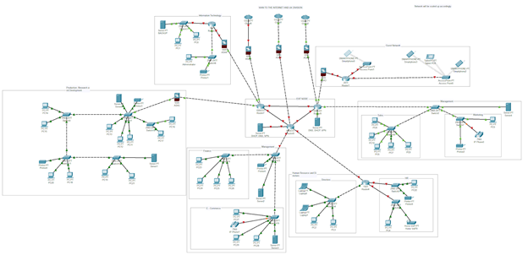

Responsibilities and Coordination:

Position | Name | Additional Responsibilities:
Network Manager/Administrator | Joe Thozhuthumparambil | Documentation and Server Configurations
Network Engineer | Kevin Remigio | Documentation and Cisco Packet Tracer Configurations
Network Technician | Khac Luc Le | Documentation
Network Technician | Yujia Luo | Documentation
Foreman | Outsourced | -
Workers | Outsourced | -

Job Responsibilities:
- Foreman and Workers - installation of network cables
- Network Technicians and Workers - installation of servers, routers, switches and PCs
- Network Engineer and Network Technicians - setting up of servers, configuring of routers and switches, network system testing and troubleshooting.
- Network Manager/Administrator - Validating system settings and long-term maintenance
- Network Technicians, Network Manager/Administrator, Network Engineer - Training workshop for employees and IT Staff

- Deliverables

Week # | Dates (MM/DD/YY): | Deliverables:
1-2 | 01/18/21 - 02/02/21 | Project planning
3 | 02/03/21 | Project proposal
4-5 | 02/04/21 - 02/21/21 | Installation of network cables
6 | 02/22/21 - 02/28/21 | Installation of servers, routers, and switches
7 | 03/01/21 - 03/07/21 | Delivery and installation of company PCs and equipment
8 | 03/08/21 - 03/14/21 | Configuring of Routers
9 | 03/15/21 - 03/21/21 | Configuring of Switches
10 | 03/22/21 - 03/28/21 | Setting up of Servers
11 | 03/29/21 - 04/04/21 | Product/service testing and troubleshooting
12 | 04/05/21 - 04/15/21 | Training workshop for IT employees of KYJK
13 | 04/16/21 | Expected date of project completion

- Procedures

- All necessary paperwork will be properly documented so it will be easier to backtrack in case a problem arises.
- Weekly tasks and deliverables must be achieved to meet the set weekly deadlines.
- All product information including price, brand and details are included in the receipt of the company.

- Budget

TechProject Solutions company pledges to assist with the installation at the address received within Canada. In addition, all products of the company come with a warranty ranging from 1 to 10 years including software and hardware. During the warranty period, staff of Techproject Solutions are ready to assist clients/customers regarding repair, maintenance, or free product replacement in case a problem arises.

Equipment / Device / Materials | Product Description | Quantity | Unit | Per Unit Cost | Total Cost
Routers | Brand: Cisco  Model: C1941-SEC-SRE/K9 | 6 | pc. | $1,566.00 | $9,396.00
Switches | Brand: Cisco  Model: WS-C2960X-24TS-LL | 13 | pc. | $840.00 | $10,080.00
Server | Brand: Cisco  Model: UCS-HD12TB10K12G | 5 | pc. | $1,538.00 | $7,690.00
Network and Server Rack | Brand: Tripp Lite  Model: SR42UBEIS | 5 | pc. | $ 2,939.99 | $14,699.95
Network Cable | Cat5e 24 AWG UTP cable | 5,000 | ft. | $60.60/1,000 ft. | $303.00
Connectors/Plugs | RJ45 - Cat5e compatible, for stranded wire cables | 500 | pc. | $10.34/100pcs. | $51.70
Software | Windows Server 2016 Datacenter 32 core | 1 | lic. key | $2,413.72 | $2,413.72
Total Equipment/Material Cost: |  |  |  |  | $45,474.37
Total Labor Cost (30% of equipment/material cost): |  |  |  |  | $13,642.31
Total Project Cost: |  |  |  |  | $59,116.68
*Prices/Total cost shown are in Canadian Dollars.

- Risk Analysis / Scope and Limitations

- Hacking/Cyber-attack (High Level)

- Update security system and maintained weekly.
Updating the security system can ensure that the whole system is protected. We can also use random verification code, after the manager type the password, he or she needs to type one more code and this code will changed every 90 second. This method can protect from hacking.

- Hash function
Our client might consider using cryptographic hashing to generate checksum as an anti-tamper. Checksum can ensure that if someone try to edit or fix the data in an illegal way, Checksum will know that at the first and execute the follow-up operation.

- Bug (Mid-Level)

Fix it on time. Software patches.
Identity and Assess risk
1. Orphaned account
2. Shared account
3. Back door access request
4. Unreviewed items
5. Out of role or out of place access

Mark down personal IP (home or other place), so the staff can login their account out of the workplace. But it needs them to identify themselves the first time when they login in another place. (Each person only can do it twice). Once they need to login in the third new device, they need to delete one of the first two records.

Once the staff member quits or transfers their job. The admin will set up an exact time when he or she will leave from their job. After that time, the system will deny all the access requests from that account. Moreover, after one week, the system will delete all the information of that member if that person is no longer a part of the company.

Make a dashboard that can monitor all the status of the network. According to SolarWinds website (solarwindsmsp, 2021), the dashboard can monitor how many devices are using the network at the same time and mark down which devices are issued or unrecognize). It will run 24 hours a day, 7 days a week, and once it has some problem, it will be reported and uploaded on the dashboard automatically. Moreover, it shows statistics about other status’, so it makes sure that our staff can protect and solve problems on time.

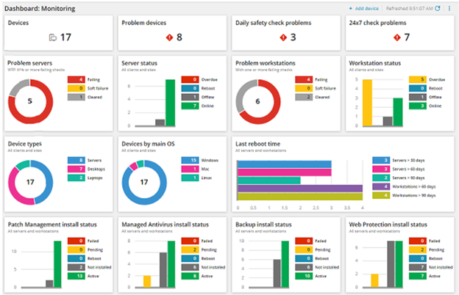
Figure 1. Example of a custom dashboard
- Scope and Limitations

The scope of this project is to design a working network infrastructure for KYJK Labs using Cisco Packet Tracer to present a visual representation of the topology that includes VLANs, trunks, DHCP servers and implementation of a RIPv2 as the routing protocol. In terms of the server side. The group used VMWare Workstation Pro 15.5 to give an example of how the client and administrator PC interact with each other with the use of Active Directory Domain Services, FTP, DNS, DHCP, and IIS.

The group was only limited to using software’s such as Cisco Packet Tracer and VMWare Workstation Pro to conduct this research and show that it works since access to Centennial College physical networking labs is prohibited at this time because of Covid-19.

TECHNICAL SECTION (Network Design and Implementation)

- Final Topology and Design Specifications

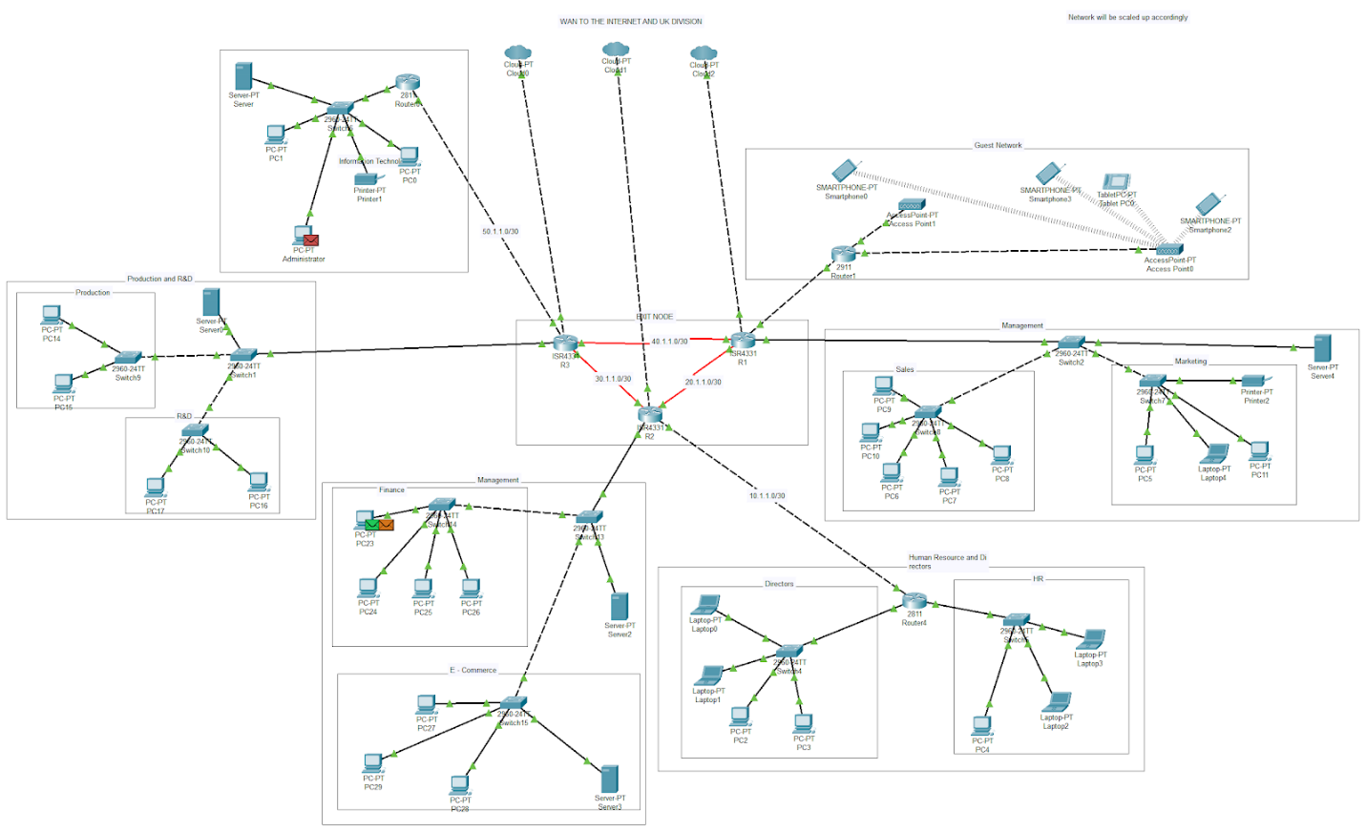Figure a.1. Shows the topology that is used for KYJK Labs, Canada

Figure a1 shows the topology of the network infrastructure made to fit the needs of KYJK Labs. There are 8 departments, and each have their own network. There are also DHCP servers to provide IP addresses automatically making it easier for IT department to manage the network which increases efficiency or productivity.
- IP addressing table (Static and Dynamic)

b.1. IP addressing table.

Table 1. Shows the Static IP addresses for IT department of KYJK Labs, Canada
PC Name | IP address | Default Gateway
Administrator | 192.168.1.3/24 | 192.168.1.1
PC0 | 192.168.1.4/24 | 192.168.1.1
PC1 | 192.168.1.5/24 | 192.168.1.1

Table 2. Shows the networks used between routers and the corresponding IP address for the routers interface.
Network between: | Network | IP address for interface
R1 and R2 | 20.1.1.0/30 | R1: s0/1/1: 20.1.1.1/30  R2: s0/1/1: 20.1.1.2/30
R1 and R3 | 40.1.1.0/30 | R1: s0/1/0: 40.1.1.1/30  R3: s0/1/0: 40.1.1.2/30
R2 and R3 | 30.1.1.0/30 | R2: s0/1/0: 30.1.1.2/30  R3: s0/1/1: 30.1.1.1/30
R2 and R4 | 10.1.1.0/30 | R2: g0/0/1: 10.1.1.1/30  R4: f1/1: 10.1.1.2/30
R3 and IT router | 50.1.1.0/30 | R3: g0/0/1: 50.1.1.2/30  IT router: f0/1: 50.1.1.1/30

The networks used for the VLANs and DHCP servers are all Class C networks and all have a subnet mask of 255.255.255.0 or /24.

b.2. VLAN table

Table 3. Shows VLANs used for the network with corresponding Network ID and Default Gateway
VLAN # - Name: | Network | Default Gateway
VLAN 10 – Sales | 192.168.10.0 | 192.168.10.1
VLAN 20 – Marketing | 192.168.20.0 | 192.168.20.1
VLAN 30 – Directors | 192.168.30.0 | 192.168.30.1
VLAN 40 – HR | 192.168.40.0 | 192.168.40.1
VLAN 50 – E-commerce | 192.168.50.0 | 192.168.50.1
VLAN 60 – Finance | 192.168.60.0 | 192.168.60.1
VLAN 70 – Production | 192.168.70.0 | 192.168.70.1
VLAN 80 – R&D | 192.168.80.0 | 192.168.80.1

b.3. DHCP server pools

Table 4. Shows DHCP servers used for the network with corresponding Pool Names, IP ranges, and their Default Gateway.
DHCP Server Name:  Pool name (VLAN #) | IP (for server) / IP range (for pools) | Default Gateway
Server 4 (provides IP to): | 192.168.10.2 | 192.168.10.1
Sales (VLAN 10) | 192.168.10.10 - 30 | 192.168.10.1
Marketing (VLAN 20) | 192.168.20.10 - 30 | 192.168.20.1
Server 2 (provides IP to): | 192.168.60.2 | 192.168.60.1
Directors (VLAN 30) | 192.168.30.10 - 20 | 192.168.30.1
HR (VLAN 40) | 192.168.40.10 - 20 | 192.168.40.1
E-commerce (VLAN 50) | 192.168.50.10 - 30 | 192.168.50.1
Finance (VLAN 60) | 192.168.60.10 - 30 | 192.168.60.1
Server 0 (provides IP to): | 192.168.80.2 | 192.168.80.1
VLAN 70 – Production | 192.168.70.10 - 25 | 192.168.70.1
VLAN 80 – R&D | 192.168.80.10 - 20 | 192.168.80.1

- List of Hardware and Software Requirements

c.1. Hardware Requirements

Hardware | Description
CPU | Core 2 Quad Q6600 at 2.4 GHz or AMD Phenom 9850 at 2.5 GHz
Memory | 4 GB RAM
Free space | 65 GB of free space
Graphics hardware | DirectX 10-compatible GPU: GeForce 9800GT 1GB or ATI Radeon HD 4870 1GB
Printer | WF-M5799 Super tank:  -Print / Copy / Scan / Fax  -24ppm5 (Mono)  -Up to 50K pages of ink6
Router | Brand: Cisco  Model: C1941-SEC-SRE/K9
Switches | Brand: Cisco  Model: WS-C2960X-24TS-LL
Network cable | Cat5e 24 AWG UTP cable

c.2. Software Requirements

Software | Description
Windows Operating system | Windows 10 Pro
Server | Windows Server 2016
Dashboard software | Bold BI

- Switch, Router and DHCP server configurations (Cisco Packet Tracer)
* check Appendix A for all the commands used for the configuration of switches and routers *

d.1. VLAN configurations

To provide security for each department, Virtual Local Area Networks (VLANs) were created so that each department has its own network and broadcast domain. VLANs were also used to make the broadcast domain smaller which makes the traffic flow faster.

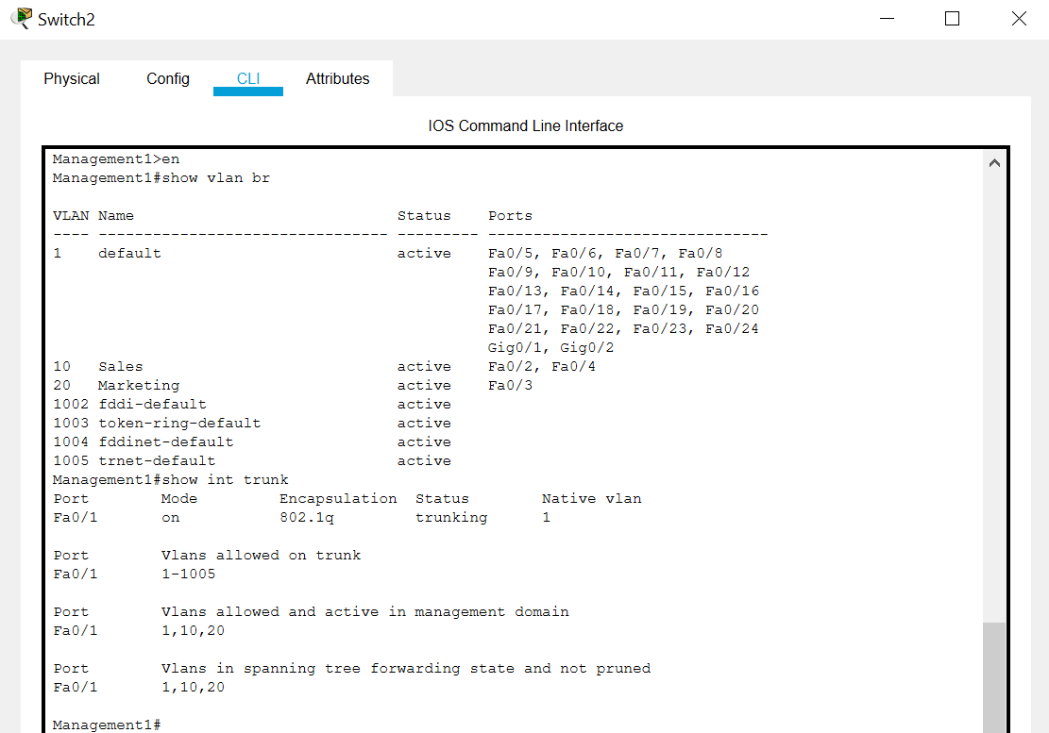Figure d.1.1. Shows port F0/1 set as trunk port and the active VLANs and their dedicated ports.

The figure above shows that port F0/1 is set as a trunk port to allow packets from both VLAN 10 (Sales) and VLAN 20 (Marketing) to pass through a single port or link going to the router. There are only 3 ports in this switch (Switch2) used for VLAN because the company wants to have a dedicated switch for each VLAN that’s why there is another switch connected to F0/3 and F0/4 dedicated for VLAN 20 PCs and VLAN 10 PCs respectively (see Figure below to provide clarity). This was the setup made for KYJK Labs because they have plans for expansion in the future, thus, it gives them access to readily available extra ports for future use rather than having just a single switch for both departments which can only accommodate a maximum of twenty-two (22) devices.

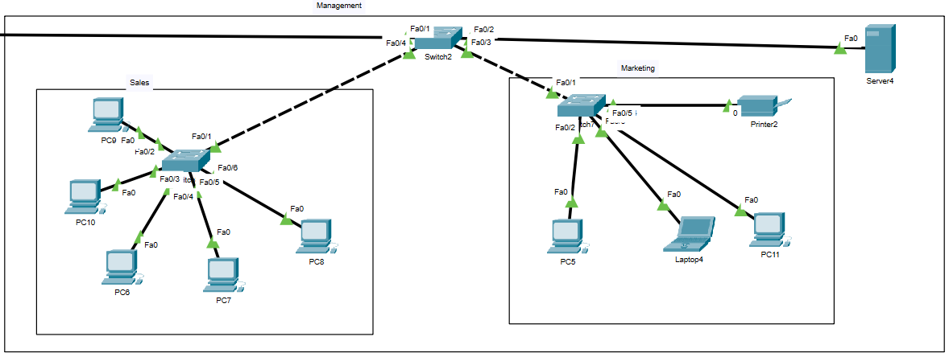Figure d.1.2. Setup for Management node.

d.2. Inter-VLAN routing

VLANs are only used to divide broadcast domains. But for a host in Sales department VLAN, for example, to communicate with another host from another department or VLAN, the traffic must be routed. Thus, inter-VLAN routing is needed. To implement this, sub-interfaces were created on the routers for each of those VLANs using the “encapsulation dot1q” command and assign necessary default gateway addresses. IP helper address was also used for the DHCP server to allocate IP addresses accordingly.

The following figures show sub-interfaces made to serve as a default gateway for the VLANs created for the network.

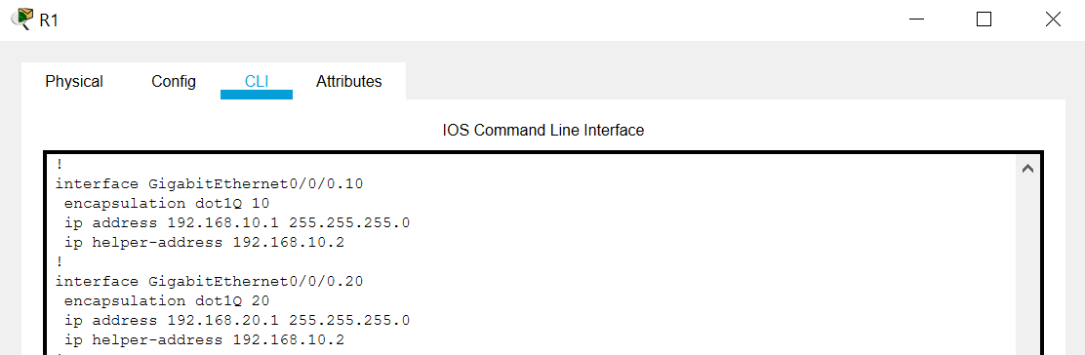Figure d.2.1. Shows sub-interfaces at port G0/0/0 in R1 to serve as a default gateway for VLAN 10 (Marketing) and VLAN 20 (Sales)

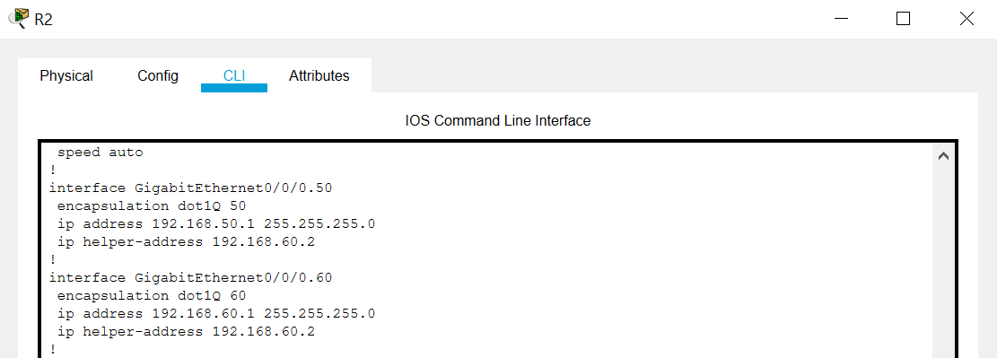Figure d.2.2. Shows sub-interfaces at port G0/0/0 in R2 to serve as a default gateway for VLAN 50 (E-commerce) and VLAN 60 (Finance)

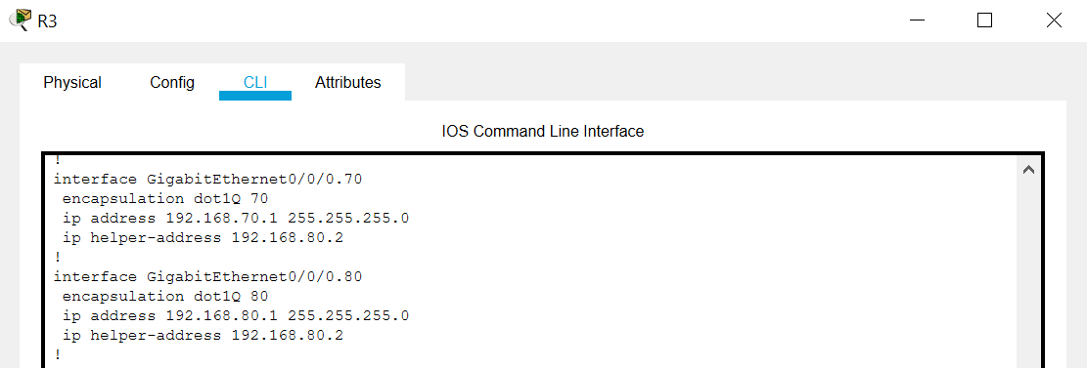Figure d.2.3. Shows sub-interfaces at port G0/0/0 in R3 to serve as a default gateway for VLAN 70 (Production) and VLAN 80 (R&D)

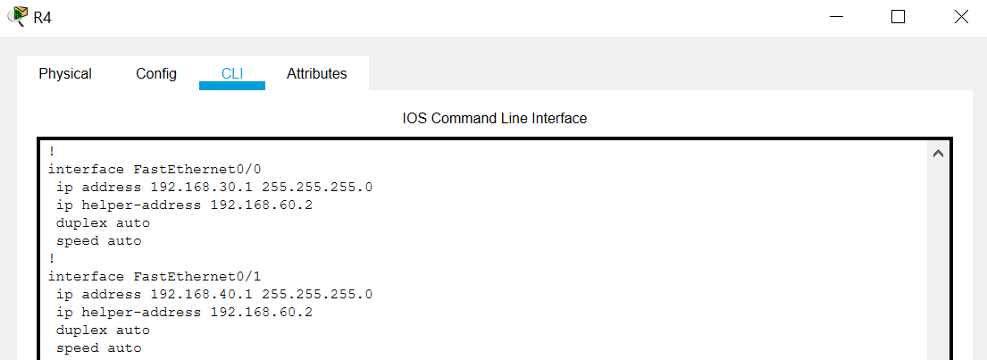Figure d.2.4. Shows interfaces in R4 to serve as a default gateway for VLAN 30 (Directors) and VLAN 40 (HR)
d.3. Routing protocol (RIPv2)

Routing Information Protocol version 2 (RIPv2) was the used routing protocol for KYJK Labs network infrastructure. It is a distance-based routing protocol which is usually used for small networks and has a max hop count of fifteen (15). Since KYJK Labs network infrastructure only has a maximum hop count of less than ten (10), based on the topology, we decided to use RIPv2.

The following figures show the routing protocol used for the network which is RIPv2.
*screenshots provided only refer to the routers at the exit node*

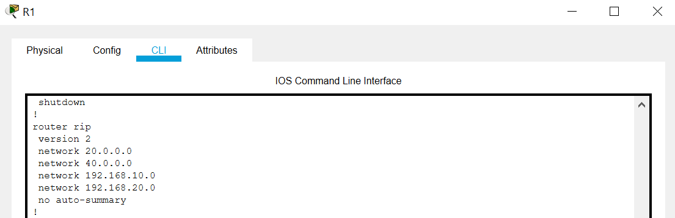Figure d.3.1. Shows RIPv2 routing protocol used for R1.

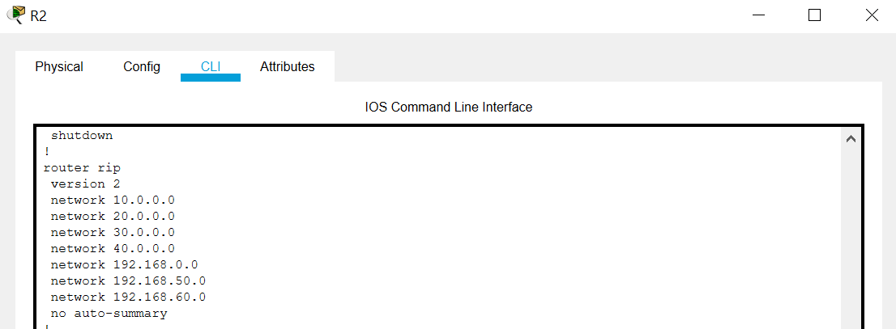Figure d.3.2. Shows RIPv2 routing protocol used for R2.

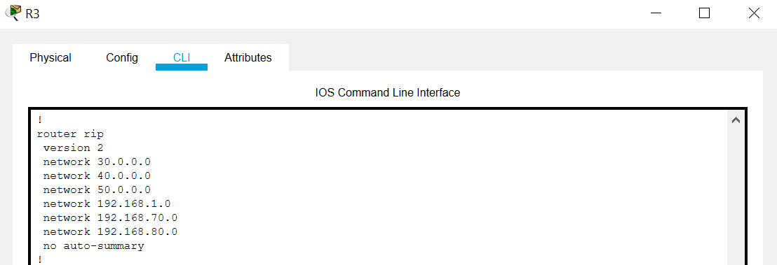
Figure d.3.3. Shows RIPv2 routing protocol used for R3.

d.4. Setting up of DHCP Servers (3)

DHCP Servers were used to automatically assign IP addresses to newly added devices/equipment on each network or department.

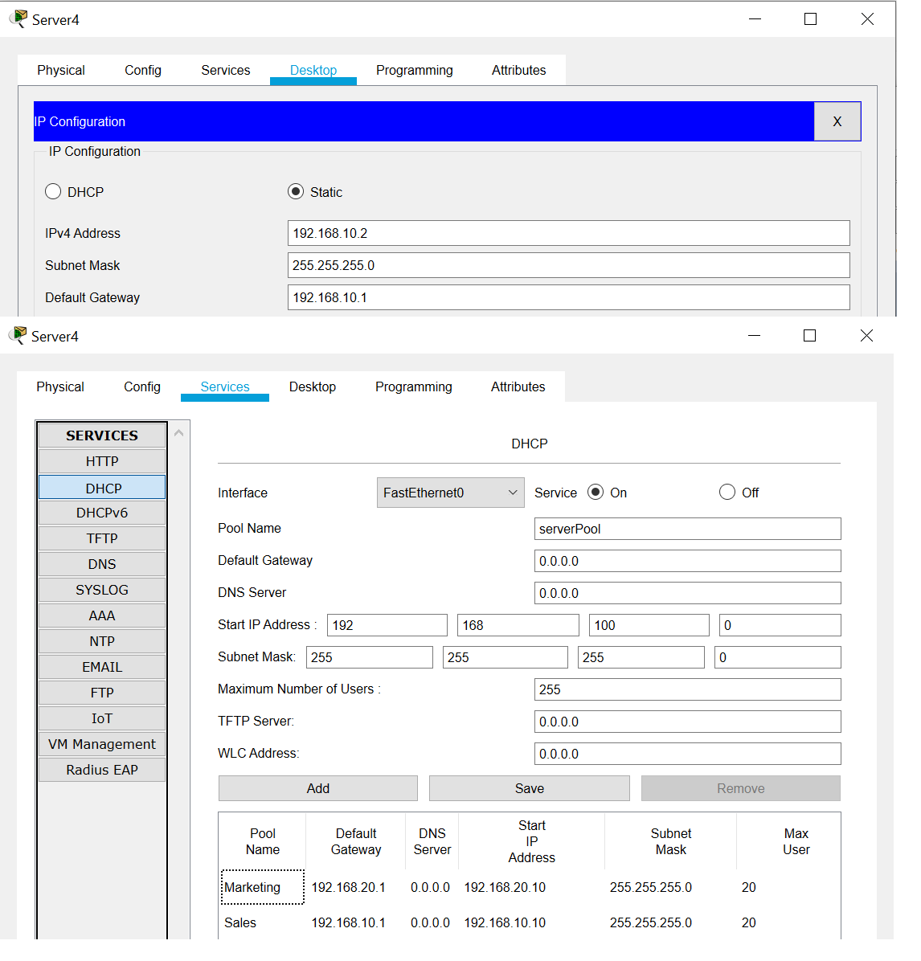
Figure d.4.1. Server4 IP configuration and DHCP server pools (Marketing and Sales) with corresponding default gateway, IP ranges, and max number of users.

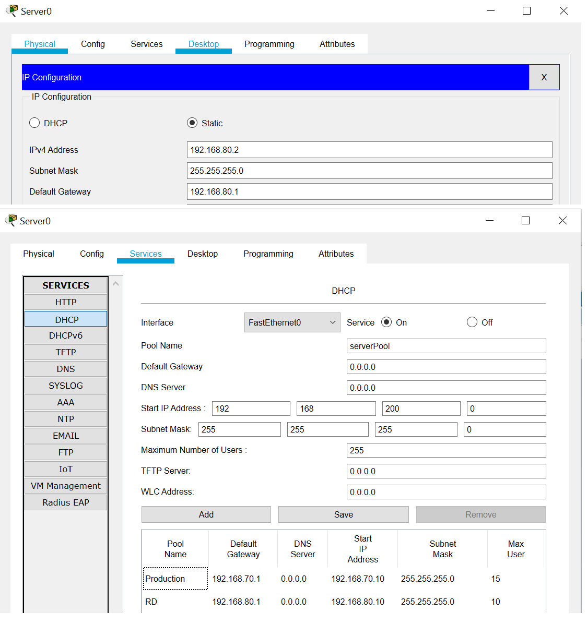Figure d.4.2. Server0 IP configuration and DHCP server pools (Production and RD) with corresponding default gateway, IP ranges, and max number of users.

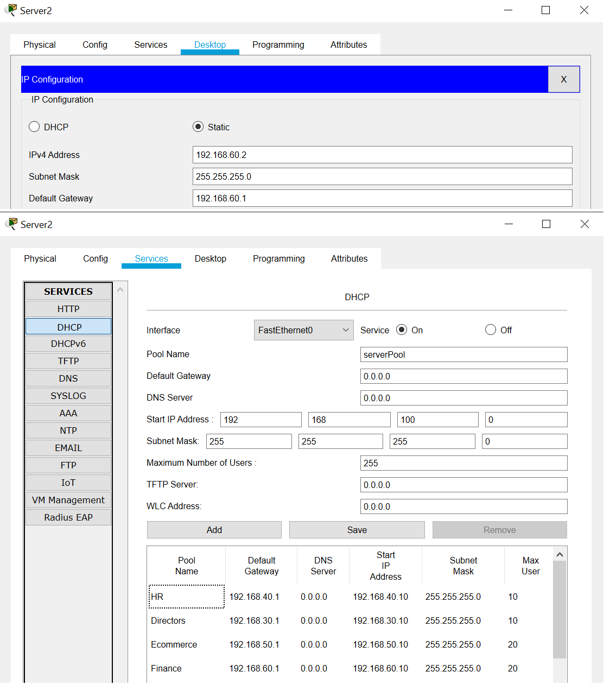Figure d.4.3. Server2 IP configuration and DHCP server pools (HR, Directors, Ecommerce, and Finance) with corresponding default gateway, IP ranges, and max number of users.

d.5. Connectivity/Service Testing

“show ip route” command was used to show all connected networks and that the whole network is working. In addition, the connections were also verified using ping commands on command prompt. A screenshot of a PC getting an IP address dynamically via a DHCP server was also provided.

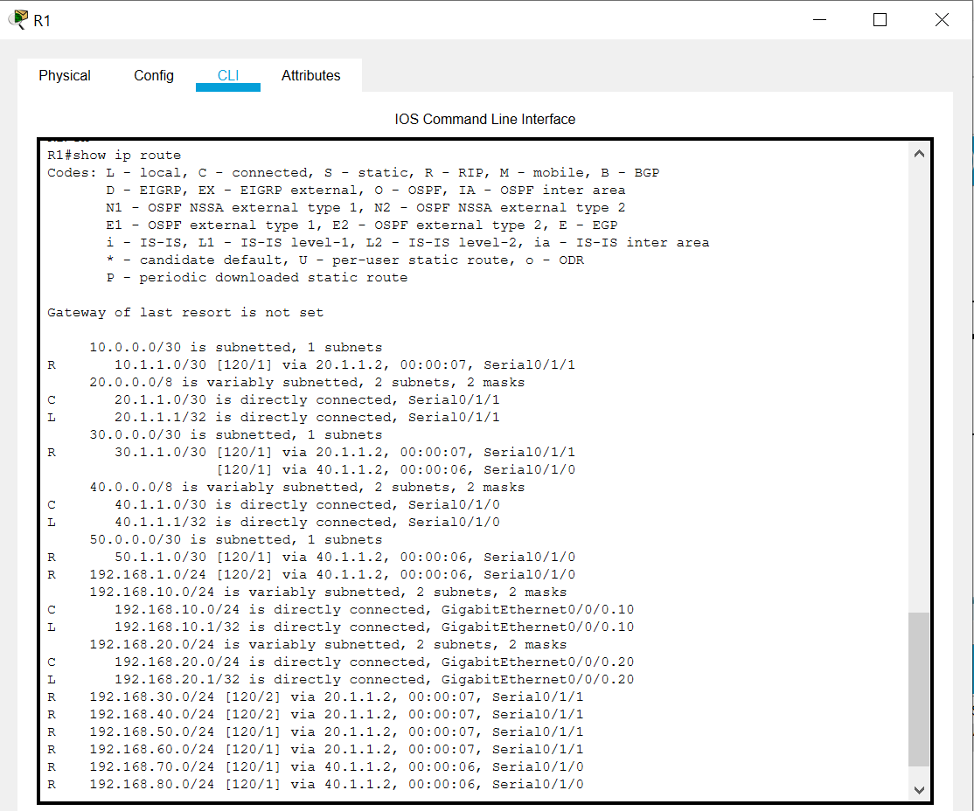Figure d.5.1. Shows networks that are directly connected to R1 and routes learned dynamically via RIPv2 routing protocol.
The figure shown above shows the results of the “show ip route command”. It shows codes R, C, and L which means the following:
- R – represents routes that was dynamically learned from another router using RIPv2 protocol.
- C – represents directly connected networks.
- L – identifies the address assigned to a router’s interface.

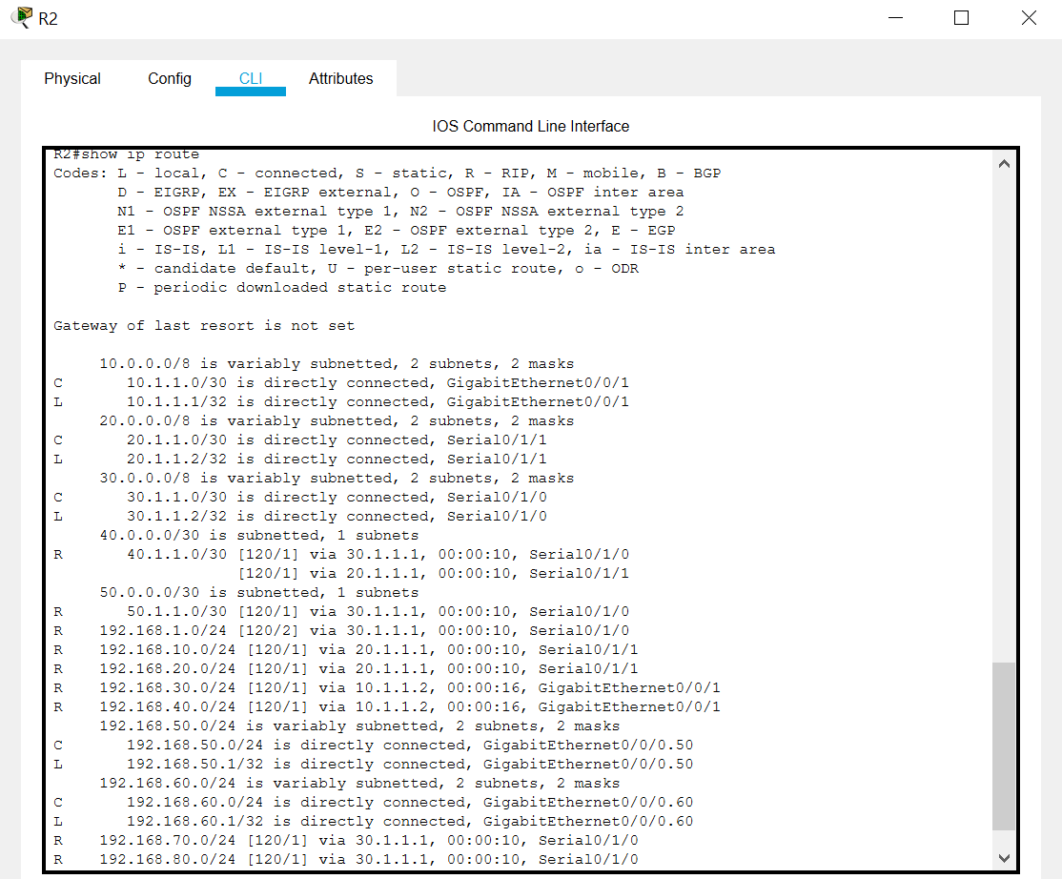Figure d.5.2. Shows networks that are directly connected to R2 and routes learned dynamically via RIPv2 routing protocol.

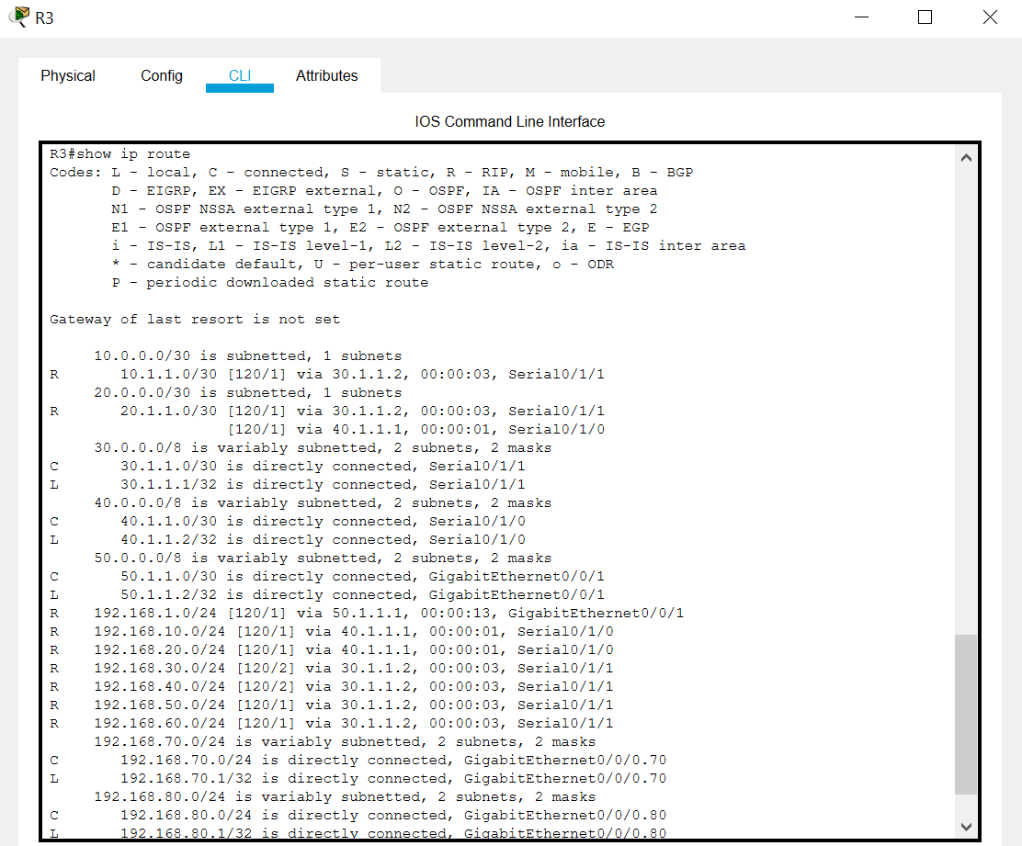Figure d.5.3. Shows networks that are directly connected to R3 and routes learned dynamically via RIPv2 routing protocol.

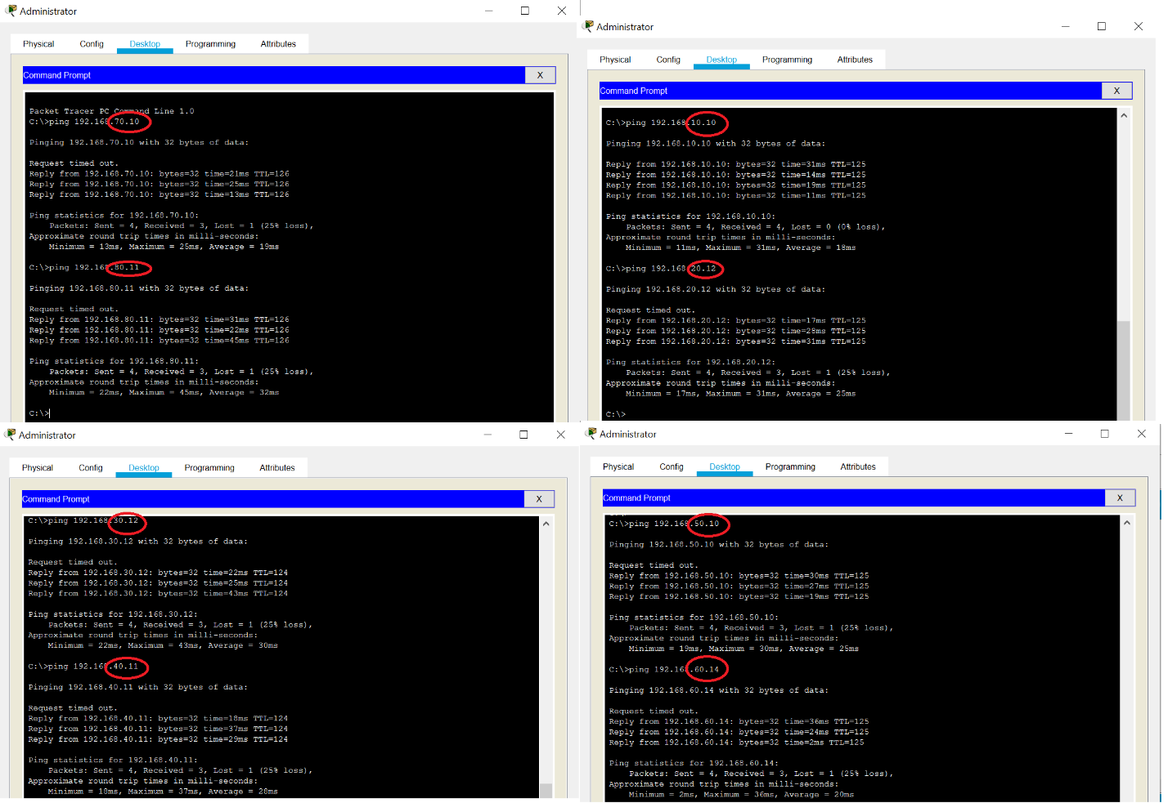Figure d.5.4. Shows successful pings from Administrator PC to PCs from different networks or VLANs.

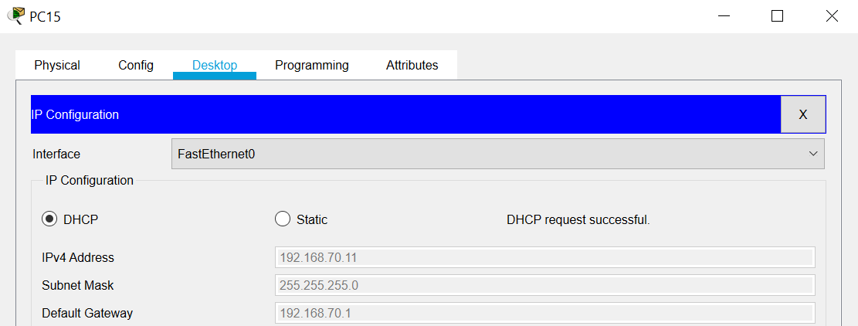Figure d.5.5. Shows PC15 being able to request an IP address dynamically via DHCP server.

- Server Configurations

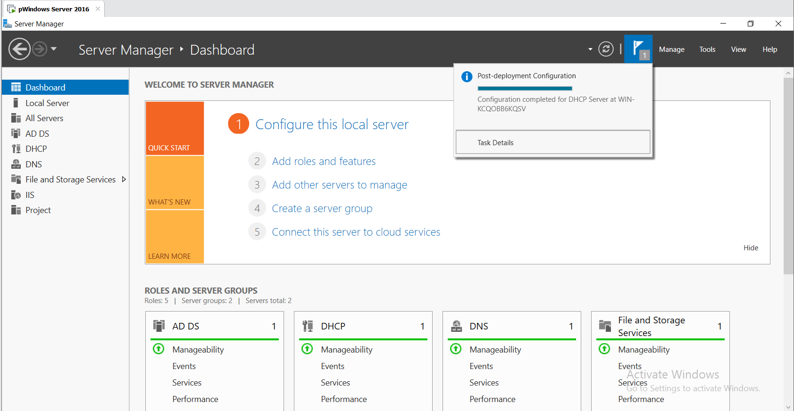Figure e.1. Showing server dashboard

The Server dashboard states all the necessary information about the configured services and the state that they operate on. Any form of error to the services wil be reflected on the dashboard.

e.1. Configure Domain on Active Directory Domain Services (AD DS)

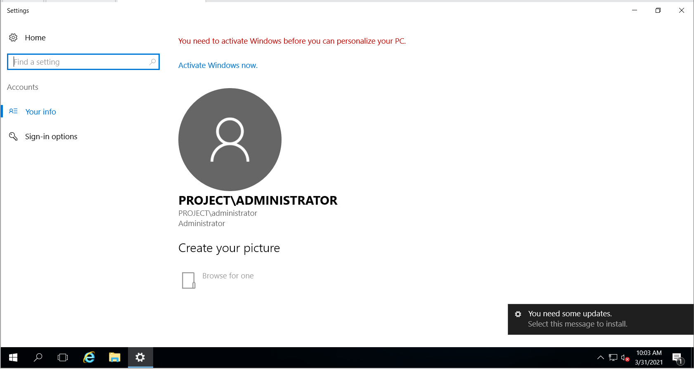Figure e.2. Administrator account in domain

The above screenshot shows the configured Administrator account of the sample domain ‘PROJECT’. The administrator account is made by default and it is the Administrator who maintains the services and users, has absolute authority over the domain and its connected devices. It is important to keep all credentials confidential to protect the domain.

e.2. Users in Domain

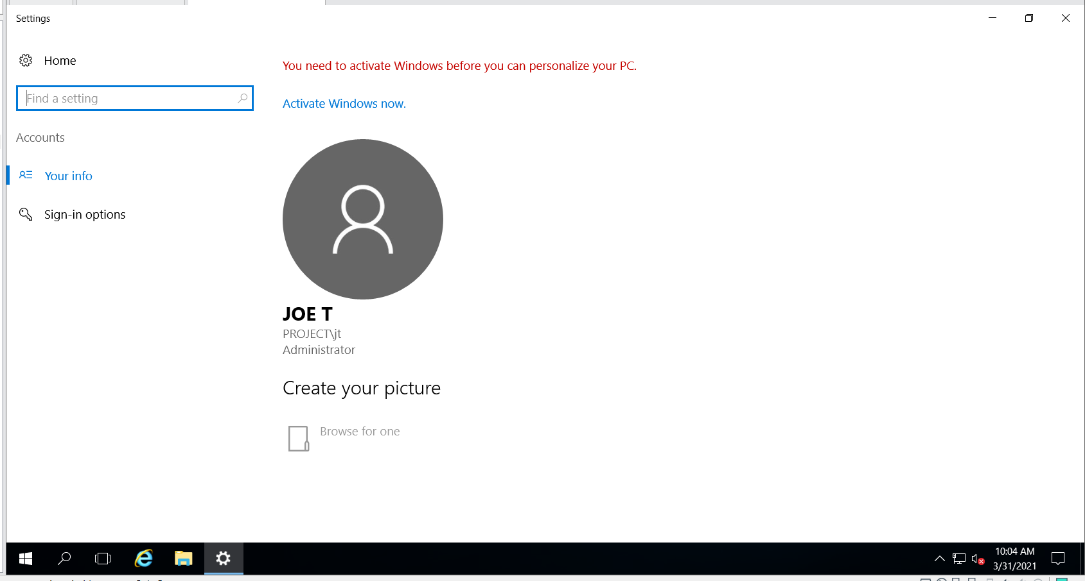Figure e.3.1 User with administrative privilege in Domain
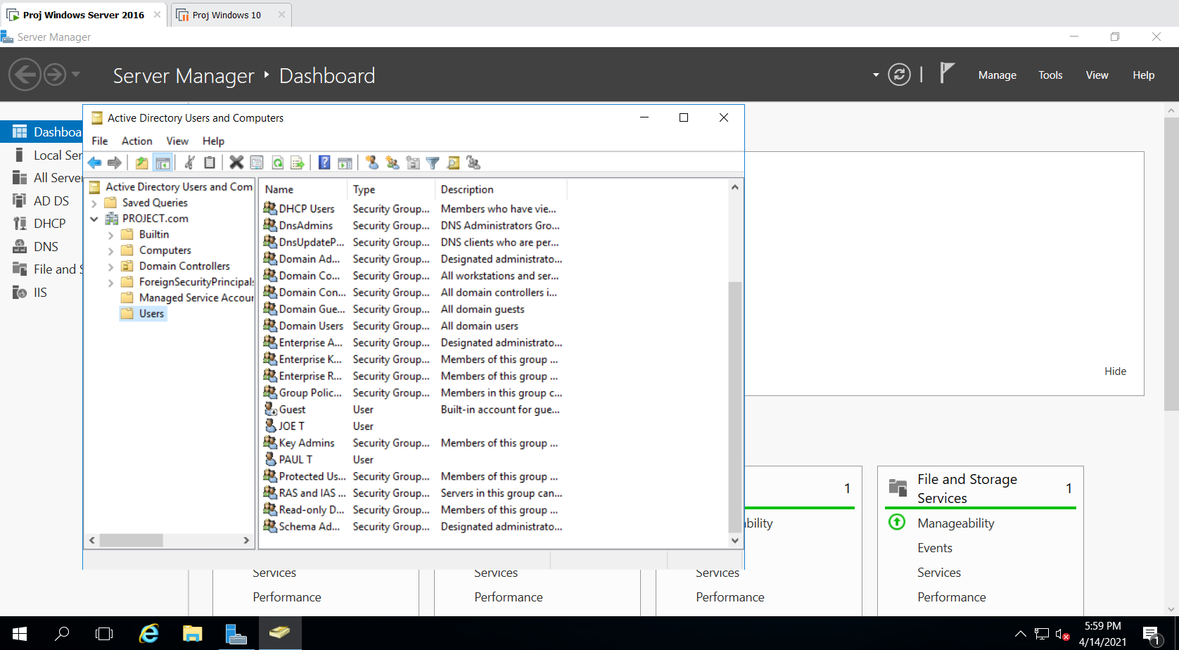
Figure e.3.2 Listing of users in Domain
Users are members of domain who uses the service offered. Everyone in the company receives a username and password. These credentials are used to authorize an individual into the domain. Active Directory Users and Computers allow the administrator to manage users that belong in the domain.

A user or a set of users known as a group can be configured to have different level of access to the services offered by the domain.

e.3. DHCP for automatic IP addressing.

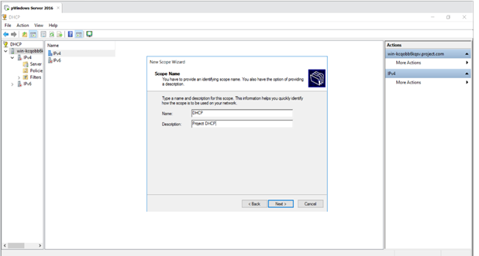 Figure e.4.1 Configuring DHCP Server

A Dynamic Host Configuration Protocol (DHCP) is used to assign IP addresses to devices connected in the scope of domain. Every modern device can support this protocol. DHCP can auto configure DNS serves and Default gateway too.

A DHCP server saves the hassle of manual configuration of IP addresses and makes a record of used IP addresses.
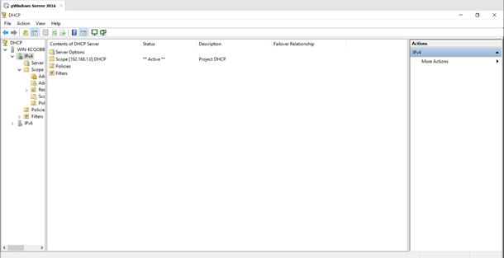 Figure e.4.2. Sample scope of DHCP Server

The Scope of DHCP server restrict the protocol to certain IP ranges where we can connect other servers and printers which require static IP addressing.

e.5. DNS Server configuration
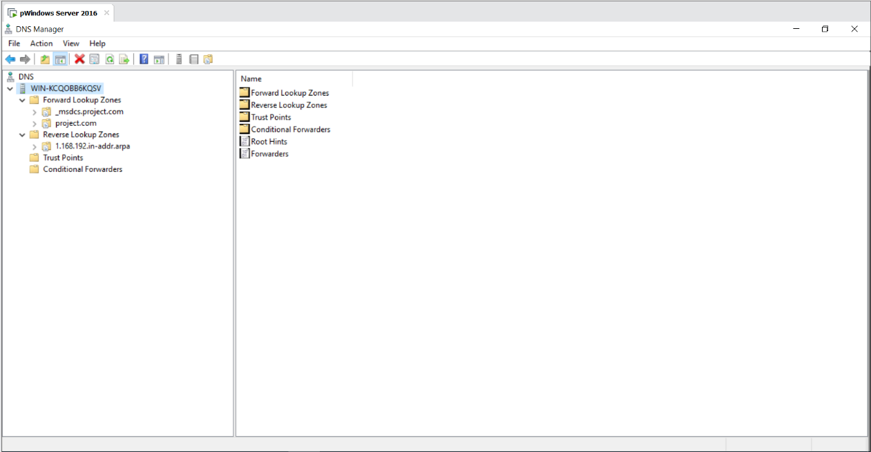
Figure e.6.1 Lookup zones of DNS Server
Domain Name System (DNS) translate web addresses to its corresponding IP address. DNS can be manually configured to add certain local websites which can only be accessed by users who are part of the domain.
Having a Local DNS server resolves hostnames faster and prevents DNS leak and reduce risk of DNS based cyber-attacks (DNS poisoning).
A DNS Server can restrict inappropriate/unproductive services on the internet easily.

e.6. FTP Server

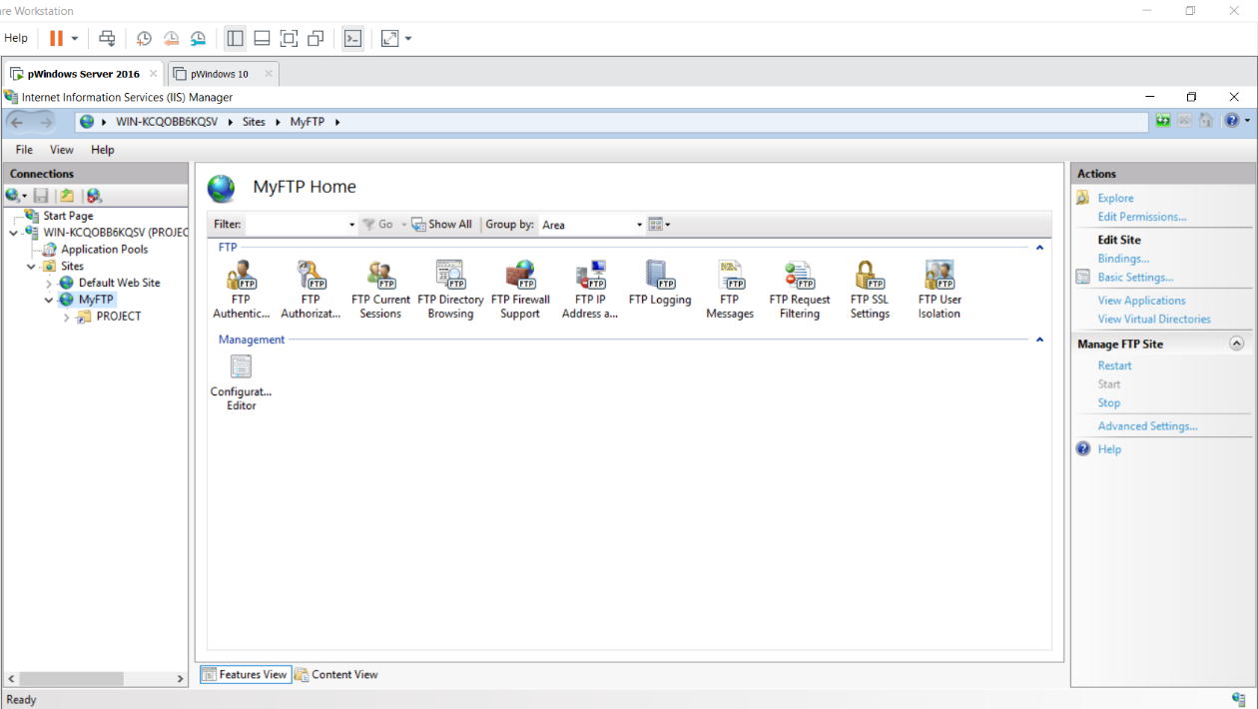Figure e.7.1. FTP Configuration

File Transfer Protocol (FTP) is a common standard used to transfer files through the internet. An FTP server allows the company to store sensitive information on-site and saves on cloud services. It reduces the risk of data loss. An FTP server will help in recovering corrupt data and administer certain level of access.
An FTP service helps in reducing data leaks and data hijack when used along network security tools.
FTP Server can restrict certain files and folders to be accessible only by privileged users and groups within the domain.
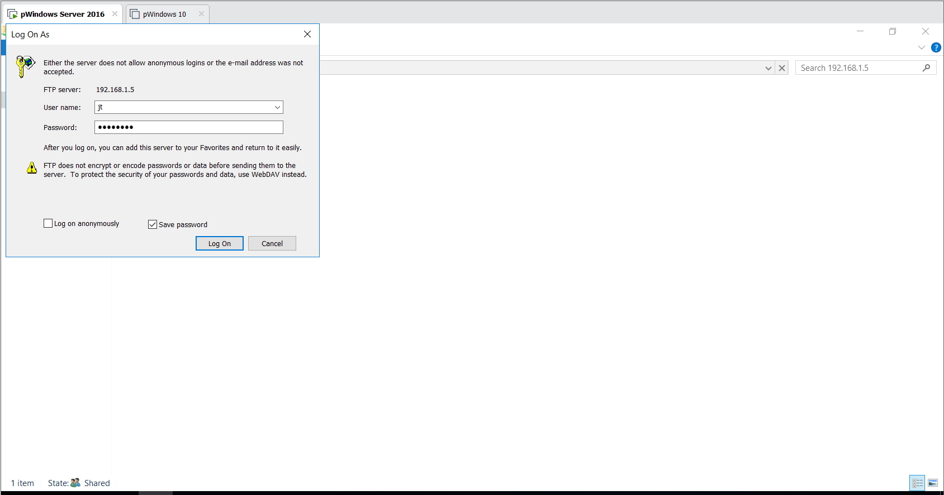Figure e.7.2 FTP Login

An FTP service can ask for a username and password which allows authorized users to view data stored in it.
FTP can be configured to use encryption. The most popular and widely used Secure File Transfer Protocol (SFTP) or File Transfer Protocol Secure (FTPS)

ANALYSIS OF RESULTS

Results shown above regarding the completed network infrastructure which was designed, installed, and deployed by Techproject Solutions have proven to be successful in delivering a fast, efficient, and secure communication and exchange of information for the use of KYJK Labs Canada. Further details are explained below.

- Speed
- Implementation of VLANs have made the broadcast domain smaller creating a network for each department, thus, faster flow of traffic.
- A Local DNS server resolves hosts much faster than traditional services.

- Efficiency
- DHCP was used making IP addressing easier for IT department, increasing productivity at the workplace.
- VLAN was used to logically group devices together, making it easy to regulate devices.
- FTP for file sharing was used to share, transfer, and store sensitive data.
- IIS hosts domain websites for the users to access features certain features like FTPS or to view sensitive information.

Security
- VLANs have made the network more secure since each department has its own network which means that if a department has been hacked or breached, other departments will not be affected.
- Domain and FTP services denies every unauthorized user access to network and its services. Authorization is mainly done through a combination of a username and password.
- DNS monitors all user activity online and can help in preventing cyber-attacks.
- FTP services provide a safe place to backup or store confidential data within the network premises.
- Having a redundant network design using RIPv2 ensures all users can access services offered by the network and network blackout does not occur.

CONCLUSION

To conclude, the group was able to complete the design and installation of network infrastructure for KYJK Labs, Canada in a span of four (4) months with a total budget of C$59,116.68. The whole network was tested before deployment and results show successful outcome of having a fast, efficient, and secure communication and exchange of information for KYJK Labs, Canada. IT staff of KYJK Labs were also trained and all systems are now ready to use for their opening in June 2021. However, this was all done in a virtual environment using Cisco Packet Tracer and VMWare Workstation Pro since access to physical labs were not possible due to the current situation or restrictions brought by the pandemic, Covid-19, which limits the group to having the true outcome of the project.

RECOMMENDATIONS

The company recommends the following for future developments and improvements:

- Improve the security features.
Since our topology is complicated and it is our duty to protect our client’s data. Improving security features like adding Cisco firewall devices, anti-virus software and requiring strong passwords should be addressed.
- Improve the dashboard.
The dashboard shown in this research is just an example, a dashboard designed based on our client’s specific requirement/needs must be taken into consideration to make sure that dashboard is fully utilized for their use.
- Keep systems up to-date.
To catch up with the latest technology, all systems must be kept up to date, so that new tools and applications can be used in the system and to prevent having problems with the system.
- Implement Access Control Lists (ACLs) on routers
Making an ACL list can ensure that only users with high privilege can access and edit secure documents and users who are not privileged cannot access sensitive information in the network.
- Add backup servers.
The backup servers can make sure that in case there is a power loss or outage or even data breach, the data can be restored or saved. To minimize data loss, backups must be saved often in secure location.
- Set application restrictions or file permissions to clients.
Some users might try to hack the application to get the information about the companies or other users. So, setting up a permission can make sure that the uses’ data and company files can be protected especially high-priority or confidential file and only authorized users in the company can access and view these files.

REFERENCES

CIRBCCRI. (2021, Feb). Home - Canada Industrial Relations Board. Retrieved from The Canada Industrial Relations Board: http://www.cirb-ccri.gc.ca/eic/site/047.nsf/eng/home

itprice. (2021, Feb). UCS-HD12TB10K12G Price Datasheet C460 M4 Other. Retrieved from Itprice: https://itprice.com/cisco/ucs-hd12tb10k12g.html

PrimeCables. (2021, Feb). RJ45 Modular Plugs for Cat5/Cat5e Ethernet Cable, 100 pcs/pack - PrimeCables®. Retrieved from PrimeCables: https://www.primecables.ca/p-317601-cab-7246-rj45-modular-plugs-for-cat5cat5e-ethernet-cable-100-pcspack-primecables

Recycled Software. (2021, Feb). Windows Server 2016 Datacenter | 32 Core | Free tech support. Retrieved from Recycled Software: https://buy.recycled-software.com/windows-server-2016-datacenter-32-core?SubmitCurrency=1&id_currency=3

Router-switch. (2021, Feb). C1941-SEC-SRE/K9 Cisco Router C1941-SEC-SRE/K9 Price, New Used. Retrieved from Router-Switch: https://www.router-switch.com/c1941-sec-sre-k9-p-149.html

Router-Switch. (2021, Feb). WS-C2960X-24TS-LL - Buy Catalyst 2960X SFP Switch 24 Port. Retrieved from Router-Switch: https://www.router-switch.com/ws-c2960x-24ts-ll-p-5264.html

Shopper+. (2021, Feb). Cat5e 24AWG UTP Solid Bulk Cable, In-Wall Rated (CL2), 1000ft - PrimeCables®. Retrieved from Primecables.ca: https://www.primecables.ca/p-353232-cab-cat5e-1000-cl2-all-cat5e-24awg-utp-solid-bulk-cable-in-wall-rated-cl2-1000ft-primecables#sku358613

Tripplite. (2021, Feb). 42U Server Rack Cabinet, Standard-Depth | Tripp Lite. Retrieved from tripplite: https://www.tripplite.com/42u-smartrack-nema-12-rack-enclosure-cabinet-for-harsh-environments~SR42UBEIS

Norris, Tim. “8 Critical Identity Risk Factors – and How to Manage Them.” CSO Online, 6 Nov. 2017, www.csoonline.com/article/3216064/article.html. Accessed 10 Mar. 2021.

“Network Risk Management.” Www.solarwindsmsp.com, www.solarwindsmsp.com/products/use-cases/network-risk-management. Accessed 10 Mar. 2021.

Appendix: (configurations for Cisco Packet Tracer)

Switch 8 > Switch 7 > Switch 2 > Server 4 > R1

Switch 8 (Sales) configurations:
enable
configure terminal
hostname Sales10
vlan 10
name Sales
exit
interface range fa0/1-15
switchport mode access
switchport access vlan 10
no cdp enable
do write
no shut
end

Switch 7 (Marketing) configurations:
enable
configure terminal
hostname Marketing20
vlan 20
name Marketing
exit
interface range f0/1-15
switchport mode access
switchport access vlan 20
no cdp enable
do write
no shut
end

Switch 2 (Trunk for Switch 7 and 8)
enable
configure terminal
hostname Management1
vlan 10
name Sales
vlan 20
name Marketing
exit
interface f0/3
switchport mode access
switchport access vlan 20
interface f0/4
switchport mode access
switchport access vlan 10
interface f0/2
switchport mode access
switchport access vlan 10
interface f0/1
switchport mode trunk
do write
no shut
end

Server 4
Static IP: 192.168.10.2
Gateway: 192.168.10.1
*Pool 1 (Sales) 192.168.10.10 – 29 (20 users)
*Pool 2 (Marketing) 192.168.20.10 – 29 (20 users)

R1
en
conf t
hostname R1
int g0/0/0.10
encapsulation dot1Q 10
ip address 192.168.10.1 255.255.255.0
ip helper-address 192.168.10.2
exit
int g0/0/0.20
encapsulation dot1Q 20
ip address 192.168.20.1 255.255.255.0
ip helper-address 192.168.10.2
do wr
end
copy running-config startup-config
conf t
int g0/0/0
no shut
end

Switch 15 > Switch 14 > Switch 13 > Server 2 > R2

Switch 15 (E-commerce) configurations:
enable
configure terminal
hostname Ecommerce50
vlan 50
name Ecommerce
exit
interface range fa0/1-15
switchport mode access
switchport access vlan 50
no cdp enable
do write
no shut
end

Switch 14 (Finance) configurations:
enable
configure terminal
hostname Finance60
vlan 60
name Finance
exit
interface range f0/1-15
switchport mode access
switchport access vlan 60
no cdp enable
do write
no shut
end

Switch 13 (Trunk for Switch 14 and 15)
enable
configure terminal
hostname Marketing2
vlan 50
name Ecommerce
vlan 60
name Finance
exit
interface f0/3
switchport mode access
switchport access vlan 50
interface f0/2
switchport mode access
switchport access vlan 60
interface f0/5
switchport mode access
switchport access vlan 60
interface f0/1
switchport mode trunk
do write
no shut
end

Server 2
Static IP: 192.168.60.2
Gateway: 192.168.60.1
*Pool 1 (Finance) 192.168.60.10 – 29 (20 users)
*Pool 2 (E-commerce) 192.168.50.10 – 29 (20 users)

R2
enable
configure terminal
hostname R2
int g0/0/0.60
encapsulation dot1Q 60
ip address 192.168.60.1 255.255.255.0
ip helper-address 192.168.60.2
exit
int g0/0/0.50
encapsulation dot1Q 50
ip address 192.168.50.1 255.255.255.0
ip helper-address 192.168.60.2
do wr
end
copy running-config startup-config
configuration terminal
int g0/0/0
no shut
end

Switch 9 > Switch 10 > Switch 1 > Server 0 > R3

Switch 9 (Production) configurations:
enable
configure terminal
hostname Production70
vlan 70
name Production
exit
interface range fa0/1-15
switchport mode access
switchport access vlan 70
no cdp enable
do write
no shut
end

Switch 10 (R&D) configurations:
enable
configure terminal
hostname RD80
vlan 80
name RD
exit
interface range f0/1-15
switchport mode access
switchport access vlan 80
no cdp enable
do write
no shut
end

Switch 1 (Trunk for Switch 9 and 10)
enable
configure terminal
hostname Factory
vlan 70
name Production
vlan 80
name 80
exit
interface f0/5
switchport mode access
switchport access vlan 70
interface range f0/6-7
switchport mode access
switchport access vlan 80
interface f0/1
switchport mode trunk
do write
no shut
end

Server 0
Static IP: 192.168.80.2
Gateway: 192.168.80.1
*Pool 1 (Production) 192.168.70.10 – 24 (15 users)
*Pool 2 (R&D) 192.168.80.10 – 19 (10 users)

R3
enable
configure terminal
hostname R3
int g0/0/0.70
encapsulation dot1Q 70
ip address 192.168.70.1 255.255.255.0
ip helper-address 192.168.80.2
exit
int g0/0/0.80
encapsulation dot1Q 80
ip address 192.168.80.1 255.255.255.0
ip helper-address 192.168.80.2
do wr
end
copy running-config startup-config
configuration terminal
int g0/0/0
no shut
end

Set DHCP Relay Agent
Switch 4 > Switch 5 > Server 2 > R2 > R4

Switch 4 (Directors) configurations:
enable
configure terminal
hostname Directors30
vlan 30
name Directors
exit
interface range f0/1-10
switchport mode access
switchport access vlan 30
no cdp enable
do write
no shut
end

Switch 5 (HR) configurations:
enable
configure terminal
hostname HR40
vlan 40
name HR
exit
interface range f0/1-10
switchport mode access
switchport access vlan 40
no cdp enable
do write
no shut
end

Server 2 (additional)
*Pool 3 (Directors) 192.168.30.10 – 19 (10 users)
*Pool 4 (HR) 192.168.40.10 – 19 (10 users)
add dhcp pool for directors and hr
R2 (additional)
enable
configure terminal
int g0/0/1
ip address 10.1.1.1 255.255.255.252
no shut
exit
router rip
version 2
network 10.0.0.0
network 192.168.60.0
no auto-summary
do wr
end

R4
enable
configure terminal
hostname R4
int f1/1
ip address 10.1.1.2 255.255.255.252
no shut
int f0/0
ip address 192.168.30.1 255.255.255.0
ip helper 192.168.60.2
no shut
int f0/1
ip address 192.168.40.1 255.255.255.0
ip helper 192.168.60.2
no shut
exit
router rip
version 2
network 10.0.0.0
network 192.168.30.0
network 192.168.40.0
no auto-summary
do wr

R2 additional (RIPv2 across R1 and R3) *passive-interface not configured
enable
configure terminal
int s0/1/0
ip address 30.1.1.2 255.255.255.252
no shut
int s0/1/1
ip address 20.1.1.2 255.255.255.252
no shut
exit
router rip
version 2
network 10.0.0.0
network 20.0.0.0
network 30.0.0.0
network 192.168.50.0
network 192.168.60.0
no auto-summary
do wr
end

R1 additional (RIPv2 across R2 and R3) *passive-interface not configured
enable
configure terminal
int s0/1/0
ip address 40.1.1.1 255.255.255.252
no shut
int s0/1/1
ip address 20.1.1.1 255.255.255.252
no shut
exit
router rip
version 2
network 20.0.0.0
network 40.0.0.0
network 192.168.10.0
network 192.168.20.0
no auto-summary
do wr
end

R3 additional (RIPv2 across R1 and R2) *passive-interface not configured
enable
configure terminal
int s0/1/0
ip address 40.1.1.2 255.255.255.252
no shut
int s0/1/1
ip address 30.1.1.1 255.255.255.252
no shut
int g0/0/1
ip address 50.1.1.2 255.255.255.252
no shut
exit
router rip
version 2
network 30.0.0.0
network 40.0.0.0
network 50.0.0.0
network 192.168.70.0
network 192.168.80.0
no auto-summary
do wr
end

InfoTech Router
configure terminal
int f1/1
ip address 192.168.1.1 255.255.255.0
no shut
int f0/1
ip address 50.1.1.1 255.255.255.252
no shut
exit
router rip
version 2
network 50.0.0.0
network 192.168.1.0
no auto-summary
do wr
end

- END -

